As parents in this fast-growing digital age, your children's digital wellbeing is of utmost importance to you. Sharing pictures of your children's growth and their day-to-day lives may seem like the norm these days, but do you know that oversharing is detrimental to keeping your children safe on social media? Children are also susceptible to the harms from the internet, especially if they have started using digital and social media from an early age.

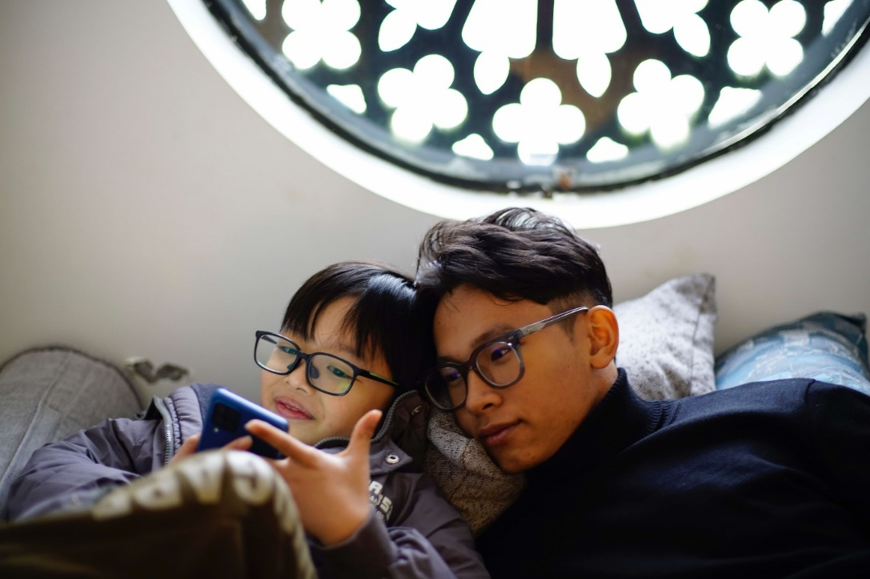

Wonder how you can safeguard the digital wellbeing of your children and adopt safer habits to share more mindfully online? Join us in a free lunch-time webinar on Safer Internet Day, 7th Feb 2023. Hear from parenting and media experts – Dr. Elmie Nekmat, Assistant Professor of Communications & New Media at National University of Singapore (NUS), Ms. Kelly Tay, Parenting Coach & Founder of Juicy Parenting, Ms. Clara Koh, Head of Public Policy at Meta, and Ms. Teresa Tan, Director of Public Policy at ByteDance. The panellists will share about the importance of safe “sharenting” – the practice of parents sharing images and videos of themselves and their children online, and how to safeguard the digital wellness of your children.

This webinar is organised by final year students from Nanyang Technological University Wee Kim Wee School of Communication and Information, supported by the Media Literacy Council and in support of the Digital for Life movement.

To sign up for this webinar please visit <https://bit.ly/btpsgwebinarsignup> or scan this QR code found in the banner. You can also submit questions during registration for the panellists to answer during the webinar.

